**GITHUB – PART-1**

1. Create a GitHub account using <https://github.com/>. Use your personal email address and official emails come with restrictions.

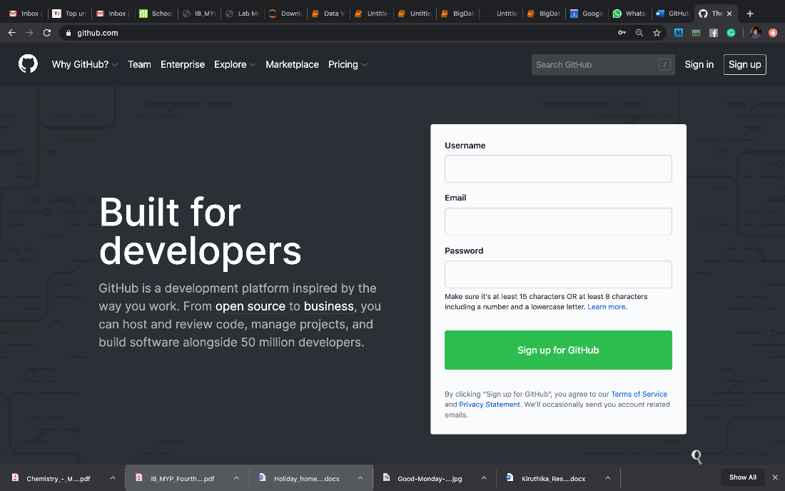

1. Create a new repository (it’s a container where all stuff goes) using the + sign as shown below:

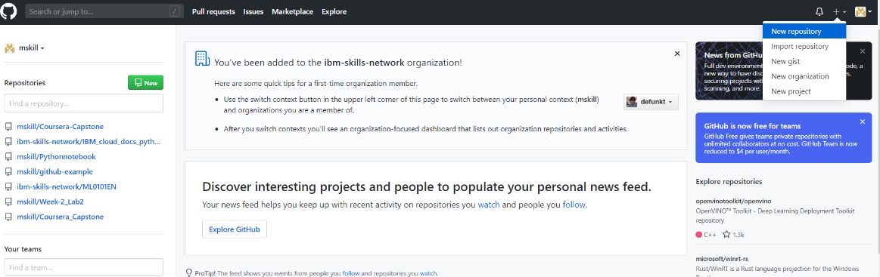

1. Provide the necessary details like repository name. Select repository as Public and initialize the READMD. Click ‘Create’

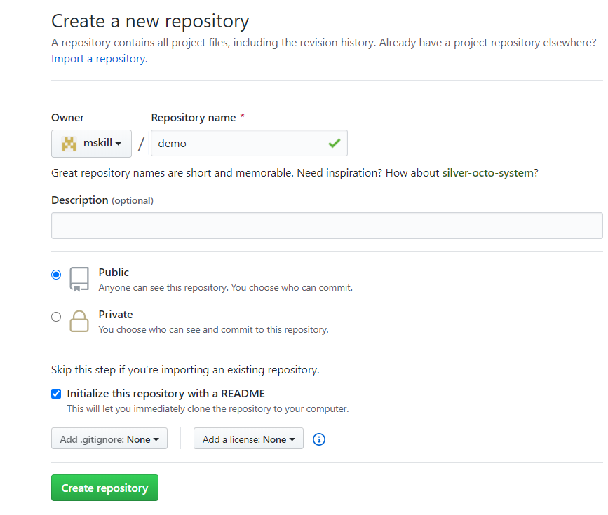

1. Now, your repository is created, and it looks as:

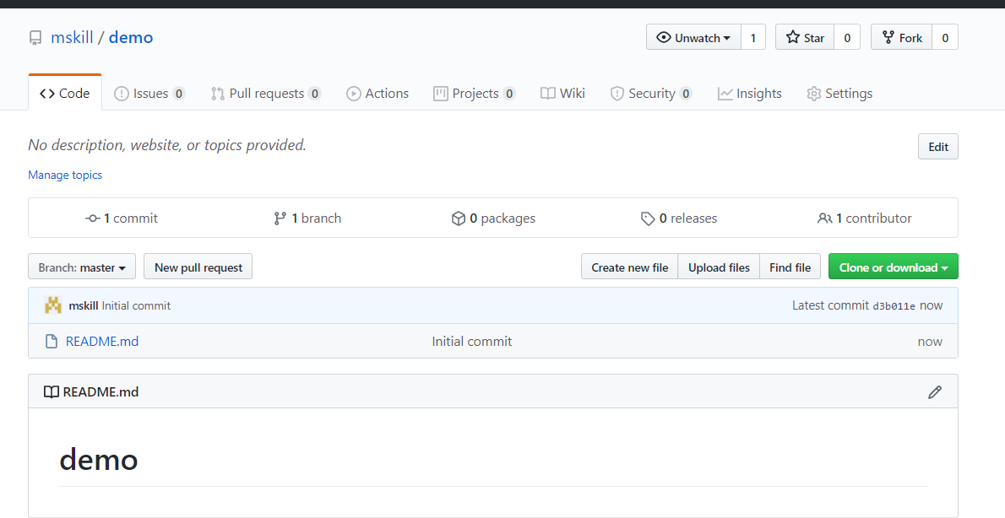

1. To download the repository, we have option ‘Clone and download’. Also, there are two options to copy repository locally using ‘SSH’ and ‘HTTPS’

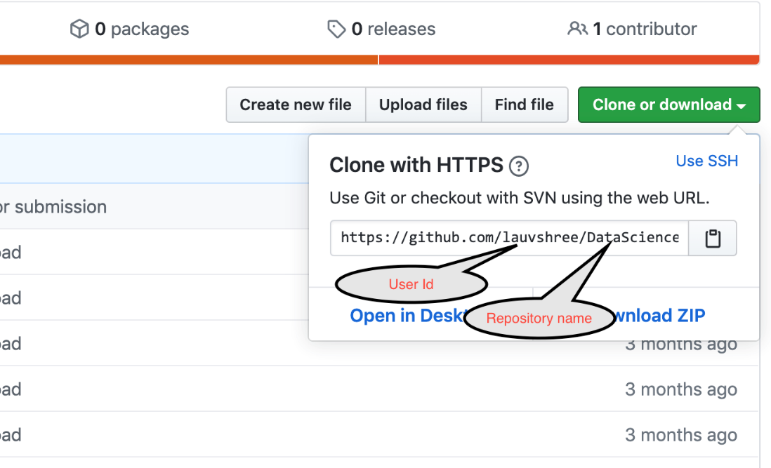

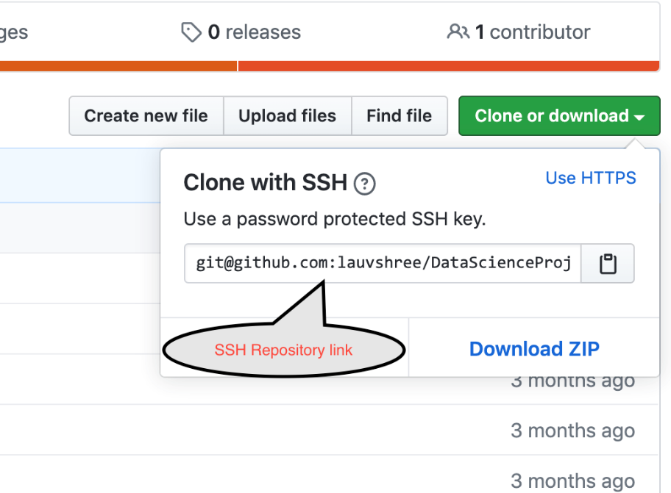

1. Copy the SSHRepositoryLink on to your clipboard.
2. These instructions presume that you have SSH key generated. However, if you don't have one please follow the step-by-step procedure in this [link](https://help.github.com/en/enterprise/2.15/user/articles/generating-a-new-ssh-key-and-adding-it-to-the-ssh-agent) before you proceed further.
3. Open the command prompt or terminal to use the GitHub commands:

To change the directory simply use:

cd <name of the directory you want to change to>

To go to the folder **“Downloads”** use: cdDownloads

Create a empty folder in Downloads using SSH repository link that we have created in GitHub Repository as:

git clone pastesshrepositorylinkhere

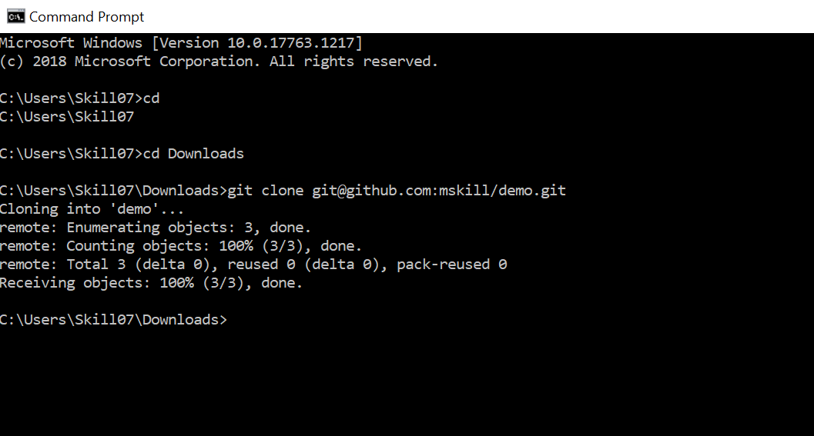

Now, the folder is copied to my ‘Downloads’. Just check the ‘Downloads’ have you got the folder demo?

1. To check my folder, enter the folder using cd command again as:

cd demo

1. Get the list of the files in the folder demo, use:

**For Windows**: dir

**For Mac**: *ls*

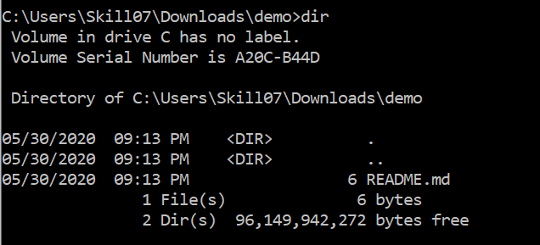

1. To view the content of the file:

**For Windows:** typeREADME.md

**For Mac**: cat README.md



1. To open a README.md file:

**For Windows:** notepad README.md

**For Mac:** open README.md

1. To create a new file:

**For Windows**: notepad test.txt

**For Mac**: vi test.txt

1. Add to the repository:

**For Windows/Mac:** git add test.txt

Check the status of the file using:

git status

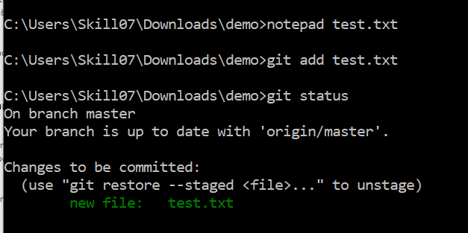

Similarly, add the new file as shown below:

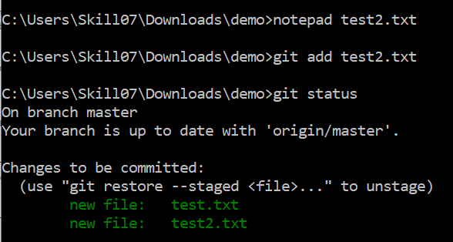

Commit the changes in the repository using:

git commit -m “write message here”

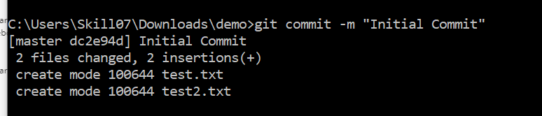

Push the file to remote repository using:

git push

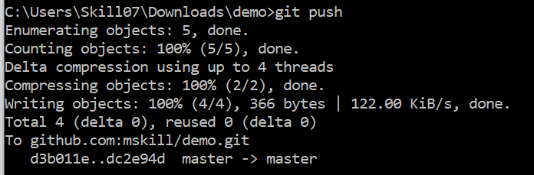

**Now, this make the changes in my GitHub repository**

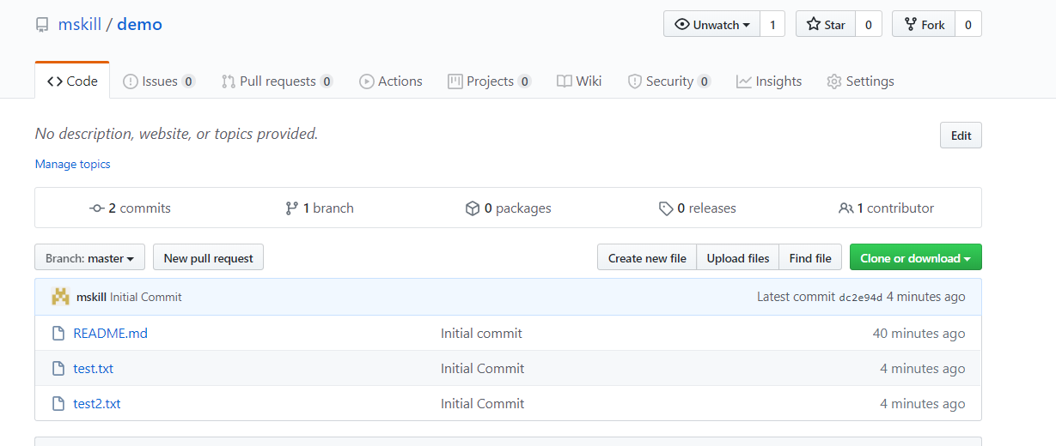

**Create a repository now without README.md file**

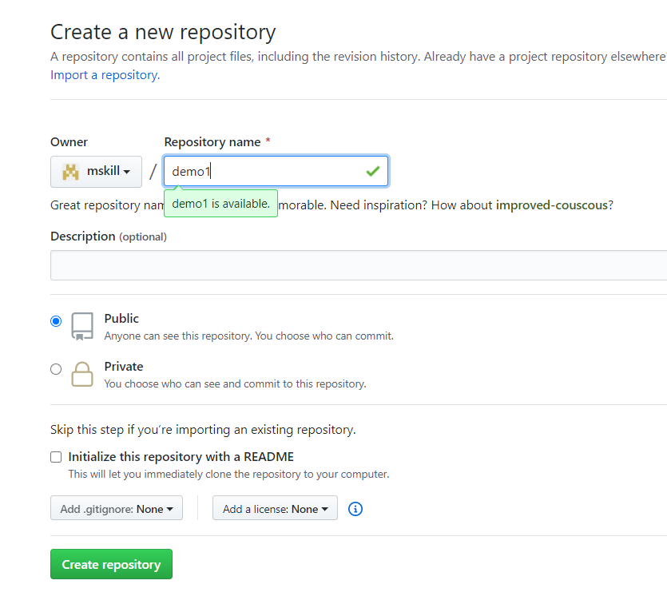

Copy the SSHRepositoryLink on to your clipboard just as in Step 6.

**To come out from the demo folder first use**

**c**d ..

To make a directory in download folder:

mkdir demo1

cd demo1

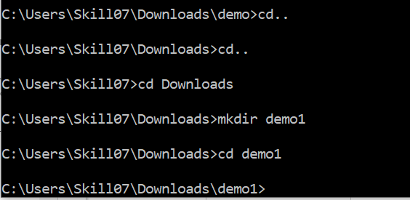

To create a readmd file use

echo "# demo1" >> README.md

Initialize the directory

git init

Create and add a README.md file. You can use a normal text editor depending on which OS you are using.

git add README.md

Check the status of the file

git status

Commit the changes

git commit -m "first commit"

Add the origin where we have to push the file. This is the SSHRepositoryLink you copied when you created the repository.

git remote add origin git@github.com:mskill/demo1.git

Push the file

git push -u origin master

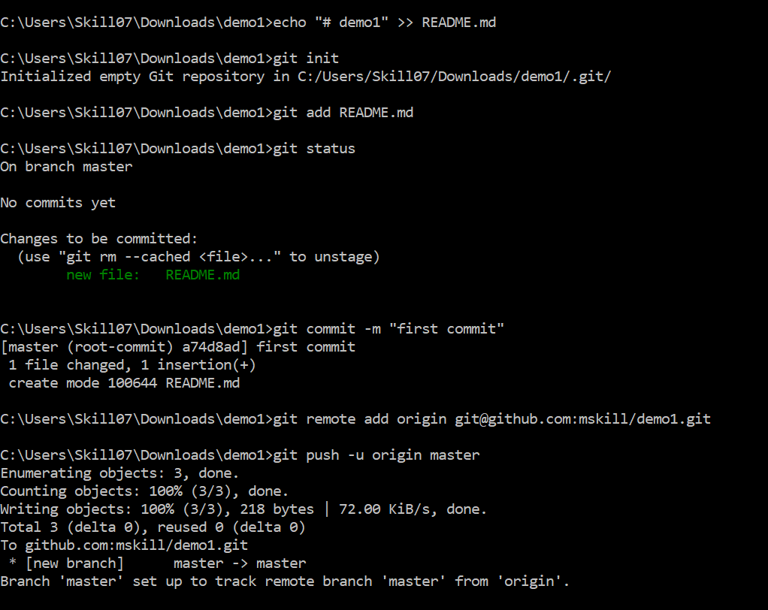

Now, the README.md file is created in our repository

